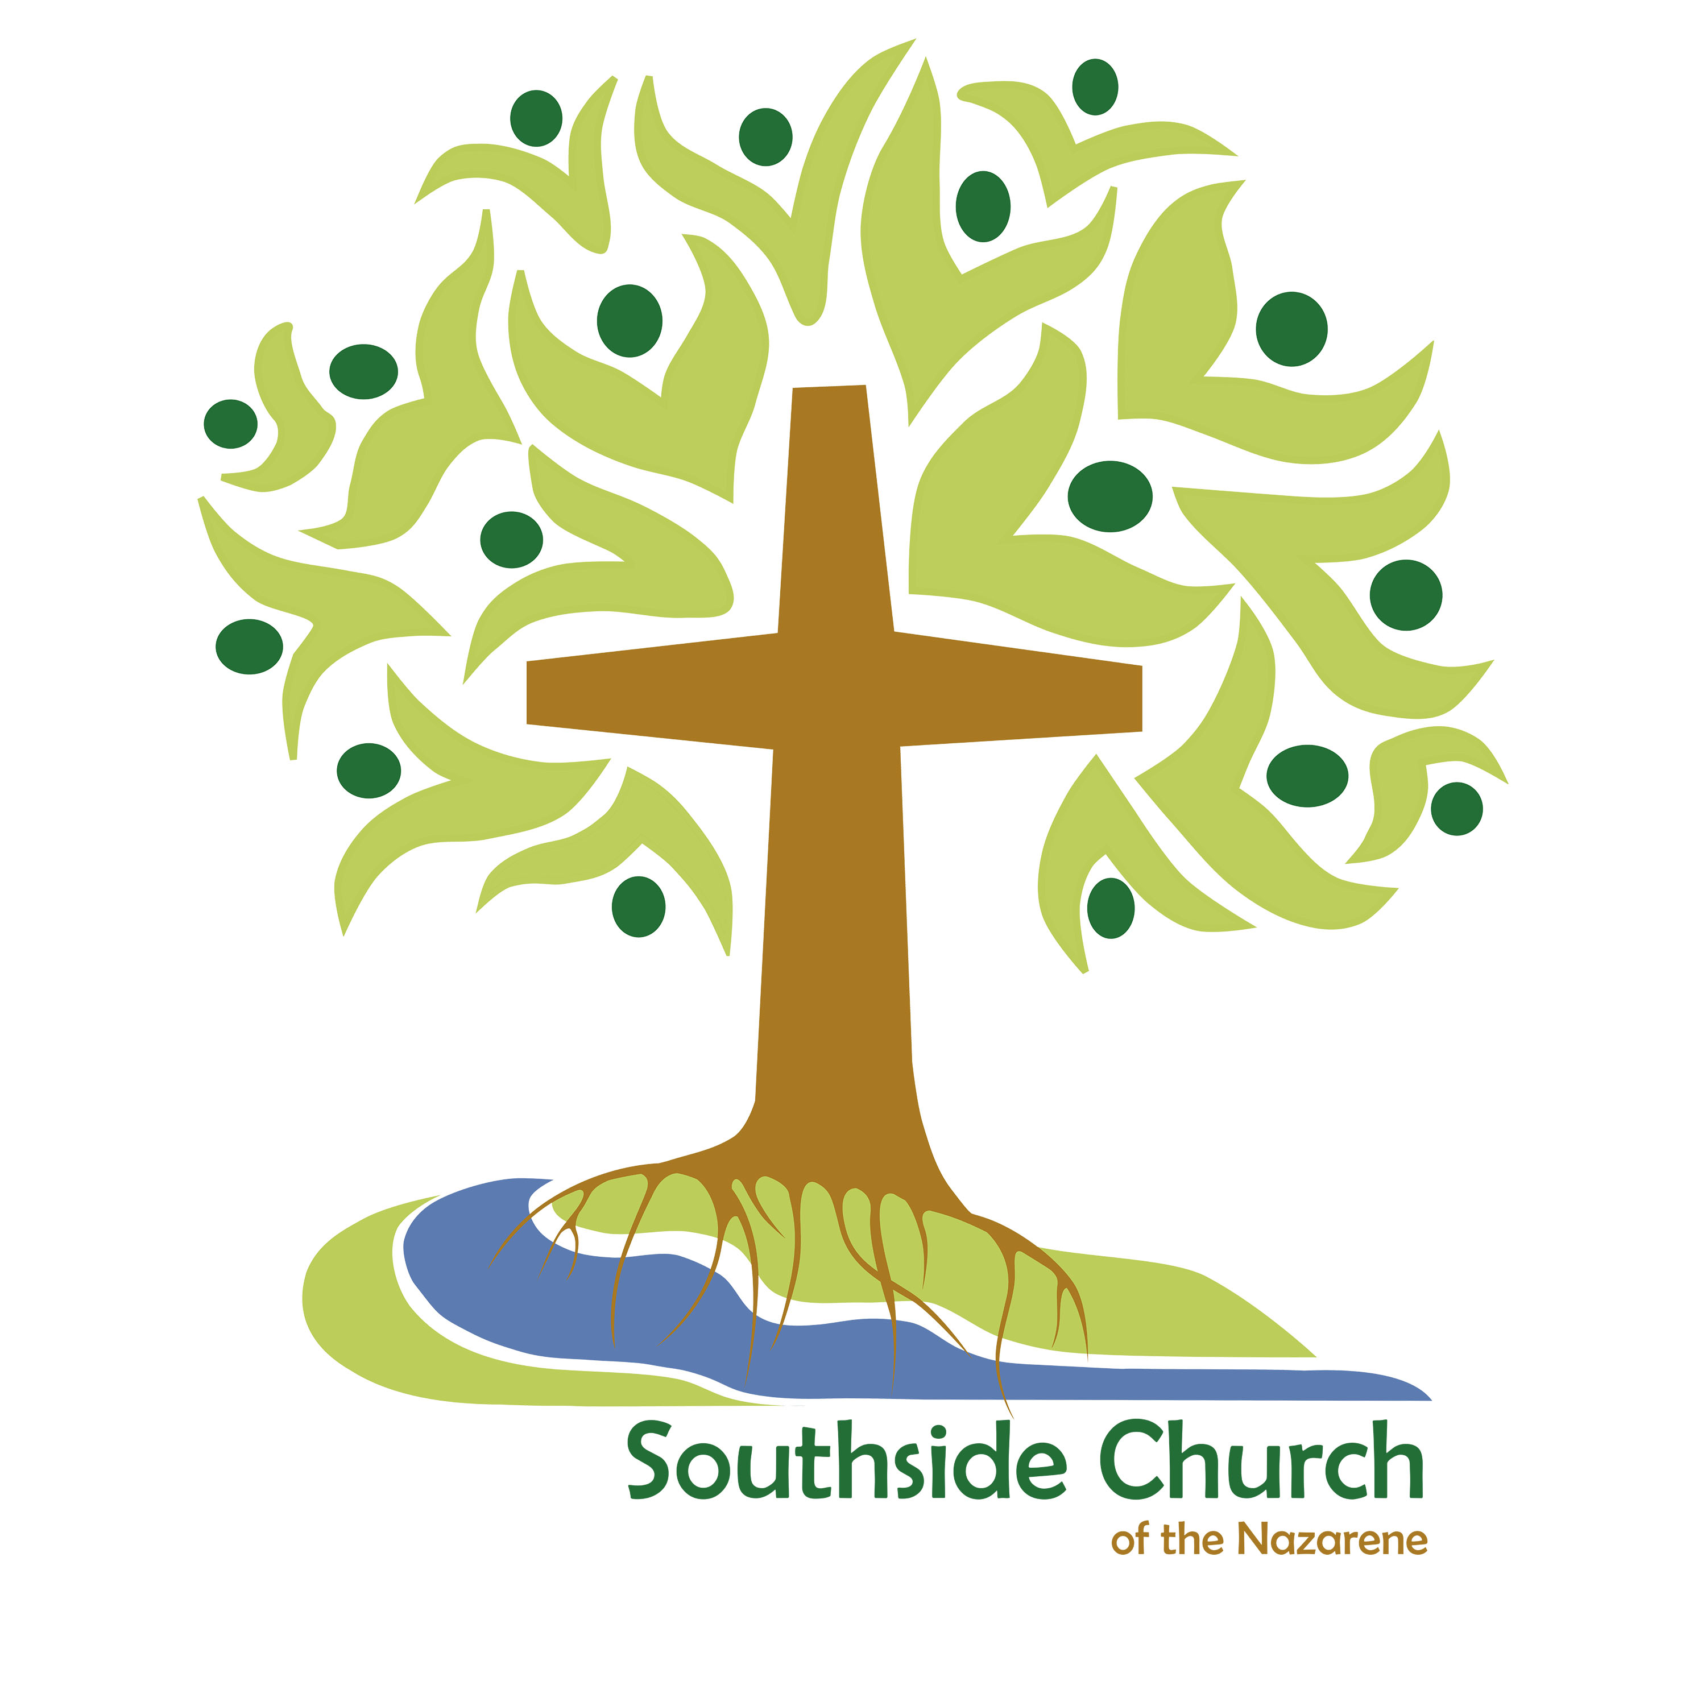

Southside Church of the Nazarene
Abuse Prevention Policy

For Children, Youth,
Vulnerable Adults and Leaders

10712 29 Avenue NW, Edmonton AB T6J 5H7
(780) 437-2217

INTRODUCTION

The primary purpose of this abuse prevention plan is to minimize the opportunity for, and hopefully avoid entirely, any incidents of abuse of children, youth or vulnerable adults through the ministries of our church. Additionally, its purpose is to enable staff and volunteers to carry out their work effectively and be protected from false or wrongful allegations. Finally, it is to reduce the church’s exposure to legal and financial liability.

The Church strives to be a loving, redemptive, nurturing fellowship - a safe place where the dignity of each person is affirmed. We recognize, however, that we live in a broken, sinful world and that even the church is not exempt from this reality. The spiritual root of all forms of abuse is the irresponsible and selfish use of power, including influence that comes in the form of otherwise legitimate and God-given trust.

We affirm that:
a) we place a very high priority on the integrity and witness of the church and earnestly desire to protect its reputation and ministry.

b) Christ put great importance on the welfare of children, as reflected in scripture. “Let the little children come to me, and do not hinder them” (Mark 10:14).

c) the protection and well-being of children, youth, vulnerable adults and ministry workers are the responsibility of the church as a whole.

d) those who work with children, youth, and vulnerable adults need themselves to be protected from wrongful accusations.

As such, we choose to be governed by the following policies and procedures.
Adopted by the church board 14 November 2017

Southside Church of the Nazarene
Nazarene Safe Policy

Recruitment and Selection of Volunteers

- A Ministry Supervisor for children or youth must be at least eighteen (18) years of age, must be a professing Christian, must exhibit Christ-like qualities in his or her life, and must read and agree to abide by the behavioural standards laid out in the Covenant of Christian Character found in the Manual of the Church of the Nazarene.

- A Ministry Helper for children or youth must be a person of good reputation within the congregation and must exhibit a cooperative attitude.

- As a general rule, we require that people must be regularly involved at the Southside Church of the Nazarene for at least 6 months prior to being approved to serve as Ministry Supervisors or Helpers. Exceptions to this rule (as in the case of a student moving to the area to attend college, and being available for involvement in the church’s ministries; or other such circumstances) will be considered on a case-by-case basis. Exceptions will only be allowed when the person has satisfactorily completed the application process as detailed under point #7 below.

- At no time shall a person who is known to the congregation to have been guilty of child abuse or sexual abuse be involved in ministry with children or youth or vulnerable adults.

- It is our policy that there shall always be a minimum of two Nazarene Safe-approved adults present in the room when ministries to children or youth are being conducted. If this is not possible an alternative approach would be to require one Nazarene Safe approved adult in the room and one Hall Monitor who would oversee several rooms.

Please note, as the number of children increase, so the number of supervising adults needs to increase, in accordance to the following guidelines:

  - 1 adult to 3 children – birth to 3 years of age
  - 1 adult to 5 children – 4 and 5 years of age
  - 1 adult to 10 children – 6 years to 17 years of age

These ratios are presented as a goal which we will always try to meet.

- Every new children’s or youth worker, including established members, must complete this congregation’s Volunteer Questionnaire, and undergo the related screening process.

- There are six important aspects of the application process which must be observed:
  - “Volunteer Questionnaire” form completed in its entirety.
  - Police Record Check: Each applicant must secure and submit a Police Record Check (PRC), and no new applicant will be allowed to begin ministering with children, youth or vulnerable adults until the PRC (or at minimum, a proof of application for same) has been received by the church. In the event that the applicant presents a proof of application for their PRC, the completed PRC must be presented within three months of the application date. All paid staff will also submit to a PRC for their own protection and for the protection of the church, and new paid staff will undergo a PRC before being employed. Any individual who will not submit to this procedure is ineligible to work in our children’s and youth ministries. Police Record Checks must be renewed every three years. Note: youths under the age of 18 are exempt from the PRC requirement.
  - Reference Check. References are required from anyone applying. If the applicant has a recent previous church affiliation or experience with a Christian ministry, then two references are required from such previous churches or ministries; if not, then the references should come from jobs or volunteer positions. There should also be at least one personal reference, from someone not related to the applicant who has known the applicant for at least three years. At least one reference in each category should be contacted and asked to confirm or comment on the information given by the applicant. The person making the contacts, the date, and a summary of the reference’s comments will all be recorded; this will become part of the Worker’s Placement File. (The Suggested Script for Telephone Follow-up will be used when screening applications).
  - Interview: subject to the discretion of the Nazarene Safe Director (NSD), an interview may be conducted with the candidate, by the NSD or by others whom she/he has trained. This allows them to review the important items from the Volunteer Questionnaire in a personal setting, to ask follow-up questions and to enhance their knowledge of the applicant. It also allows the applicant to ask questions about the ministries and the reasons behind the prevention procedures.
  - Completion of training session(s) as prescribed by the church (see below).
  - Approval (see below, para. 9)

NOTE: The information contained in the PRC’s is considered confidential. Only the Senior Pastor and Nazarene Safe Director shall be privy to the information. If there is a record or information which raises some concern, the NSD and/or Senior Pastor will first meet with the applicant to discuss the matter and then meet privately to discuss the matter. If the concern is related to something other than child or sexual abuse, the volunteer may proceed with the application process provided there is agreement from all church representatives involved.

- The Nazarene Safe Director (NSD) will keep records of the status of the application process for all ministry workers. At the completion of the process, all documentation will be filed in the church office with provisions made for confidentiality. These records shall be retained indefinitely.

- All new workers must be approved by the Pastor (and Nazarene Safe Director) before being allowed to begin ministry to children, youth or vulnerable adults. Applicants may be denied at the discretion of the Pastor, and where there is any history of abuse, assault, violent tendencies, etc., these will be taken with utmost seriousness. The Senior Pastor, in consultation with the District Superintendent, shall have the right and authority to deny anyone the privilege of working with children or youth or vulnerable adults in the local church at his/her discretion. Working as a volunteer in the church is a privilege and not a right. Protecting the children, youth and vulnerable adults of the church is a duty of the pastor. Any suspicion, cause for concern, or discomfort about any person shall be thoughtfully reviewed by the Pastor and his/her decision shall be binding and final. The Pastor shall not be required to give any explanation for the decision.

Training

All children’s and youth workers along with those working with vulnerable adults must receive training regarding child safety, child abuse and sexual abuse prevention. This applies to existing workers as well as newly appointed workers.
- The training program will be based upon “A Handbook for a Safe Place,” produced by the Church of the Nazarene Canada and contextualized by the Southside Church of the Nazarene and will also utilize video and other content from www.nazarenesafe.org. It will include the following:
  - An overview of this policy;
  - Instruction on properly defining, recognizing and reporting signs of abuse;
  - Instruction on proper supervision, appropriate physical boundaries and suitable methods of care and discipline for children and youth;
  - Instruction on how to recognize a potential child/sexual abuser.

- The church will provide, at least annually, a training session on its Nazarene Safe Policy, and on related topics such as recognizing signs of abuse, updates on government regulations, etc.

- Prospective workers must complete the training prior to approval as children’s/ youth/vulnerable adult workers. See para. 8 under Recruitment and Selection of Volunteers.

- All workers will be required to attend updated training every year, at times determined by the Senior Pastor or NSD.

- Upon completion of training, all workers must sign a record indicating they have been trained and have read through the Safe Place Policy and Procedures. These records must be kept in the worker’s personal file. See para. 8 under Recruitment and Selection of Volunteers.

Responding to Allegations or Complaints

The following guidelines will govern our response in the event of an allegation that abuse has occurred. We will:

- Take all allegations seriously and handle them compassionately and within reasonable timelines. Response will include attempting to obtain a signed and dated, written statement from the alleged victim; assuring the alleged victim and their family that we will follow through with all reasonable diligence; and also assuring them of the church’s intention to extend whatever care and support is deemed reasonable given the circumstances.

- Carefully document the allegation and all actions taken in handling and responding to the allegation, and keep these records up to date.

- Employ professional outside assistance in handling the allegation, and immediately report the allegation or incident to our insurance company, the District superintendent and our lawyer.

- Contact the proper civil authorities following the guidance of the church’s insurance company and lawyer.

- Secure the safety of the child or youth or vulnerable adult, and seek professional advice before confronting the accused.

- Treat the accused with compassion. If the accused is a church worker, that person will be relieved temporarily of his or her duties until the investigation is finished. If the person is a paid employee, arrangements will be made to either maintain or suspend his or her income until the allegations are cleared or substantiated. The suspension from duties and responsibilities should not be seen as an indication of the “guilt” of the individual, but only as an indication of the priority given to protect all those involved pending the outcome of the investigation.

- Reach out to the alleged victim and their family, showing care and support. We will extend pastoral resources as needed.

- Communicate with the congregation in a way that seeks to protect the victim, the accused and the church. Communication with congregation members will be on the basis of their need to know, under the restrictions of a qualified privilege.

- Respond to media inquiries through a designated spokesperson (usually, the Senior Pastor or Church Board Secretary), who will communicate with the media regarding the matter, in a discreet, truthful and diplomatic way that seeks the protection of the victim, the accused and the church.

- Have the church’s lawyer present while answering any investigative questions from the police or social service agencies.

Prepared Position Statement

“It is always tragic when children are abused or exploited. The Southside Church of the Nazarene strongly desires to maintain a safe environment for all children and youth, and for those who work with them. We have taken all reasonable precautions to create such an environment. We have since 14 November 2017 had in place an Abuse Prevention Plan which addresses such issues as careful selection, screening and training of workers, responsible supervision of workers, and detailed reporting procedures.

As for the specific allegation at hand, we will take reasonable steps to address any needs in this situation. For the welfare of those involved, an investigation has been initiated and all relevant information has been directed to the (insert name of appropriate agencies and authorities).”

